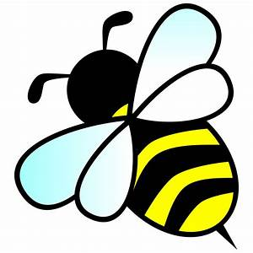
Summer Bee Trail around Huntly

Orbs Bookshop have hidden a Bee in
some of the independent shops in Huntly.
These shops will have a small Bee in a window and a Bee object or book inside. 14 in all

Note down what you find in each shop and make up a slogan about bees. Return your form to Orbs Bookshop,10 ½
The Square Huntly by the 26th of July 2023’

The Butcher’s Shop

The Hardware Shop

The Optician’s Shop

The Licensed Grocer’s Shop

Two Pharmacies

The Florist’s Shop

The Dry Cleaner’s Shop

The Bookshop

The Fish and Chip Shop

The Ice Cream and Sweetie Shop

The Ethical Gift shop and Refillery

Two Barber’s Shops

Your slogan about bees

Your name + contact details

Information about bumble bees, solitary bees and honey bees
www.bwars.com/content/beginners-bees-wasps-and-ants to identify bees
www.bumblebeeconservation.org for lots of bumble bee information
www.aberdeenbeekeepers.net/ for local honey bee information

